**1. The connection has timed out. The server at 24.228.100.92 is taking too long to respond.**

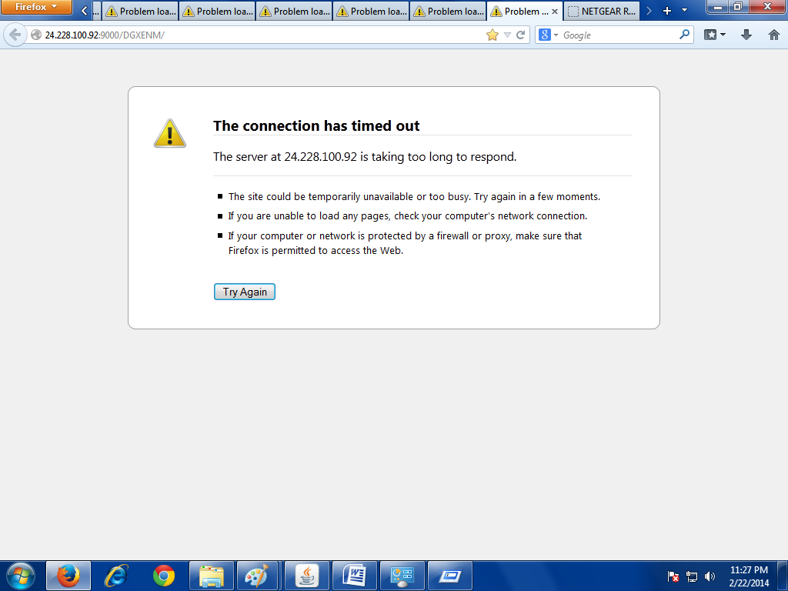

**1. SOLUTION: Go to your Network Connections > Right Click Local Area Connection > Properties > Click Properties again for the proper Internet Protocol Version > Enter the IP mapped to the Port Forwarding / Port Triggering for Tomcat. You can get the IP Address from the Router Configuration and the rest by typing "ipconfig /all" on the command prompt.**

**As of now It's the following.**

**IP Address = 192.168.1.90**

**Subnet Mask = 255.255.255.0**

**Default gateway = 192.168.1.1**

**Preferred DNS Server = 192.168.1.1**

**Alternate DNS Server = BLANK**

**1. SOURCE**

Memory ;)